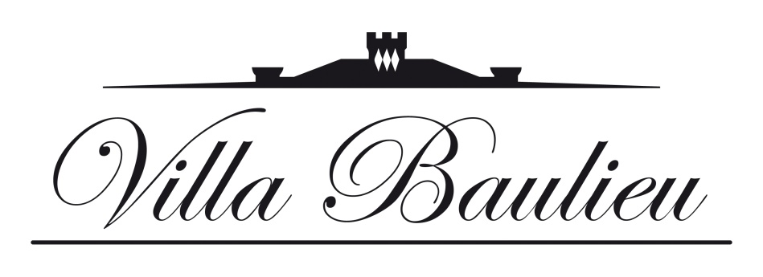

PROVENCE / LUBERON / ROGNES (VILLA BAULIEU)

The heart of Provence beats in these hills set between the Mediterranean and the Alps.
Lavender fields, rows of olive trees, hillsides of vineyards, perched villages ... the Luberon in Provence unfolds landscapes of breathtaking beauty. Song of cicadas, aromatic fragrances, Mediterranean flavors ... the region capsizes your senses!
With its Mediterranean climate and 300 days of sunshine a year, Provence expresses its art of living on the shaded terraces of the squares of its villages and seduces every year tourists from around the world.
The region also offers a rich and constantly renewed cultural offer with its famous festivals of music and theater.
Let yourself be lulled by the wonders of Villa Baulieu Park
Relax by the pool, walk in the historic park of 22 hectares, tennis or bike in the area of 300 hectares ... To accompany you in your wanderings, information panels are installed throughout the area, a well thought out route for you discover all the wonders that surround these majestic places.
Discover the wines of Domaine Villa Baulieu
The oenologist of Villa Baulieu offers you a visit of the cellars and a tasting of the wines of the property. You will also be able to accompany your tasting with a discovery of the cheeses of the region.
Discover the unique Volcano of Provence
Villa Baulieu is located in a unique area, in the very heart of the crater of an ancient volcano. Accompanied by a guide, go hiking in this exceptional landscape.
Give yourself a break
Whether it is a massage in your room (or why not in the vineyards!), A hammam or a hot tub in one of the towers that dominate the vineyard, Villa Baulieu offers unforgettable wellness experiences such as the essential massage with two or four hands with scents of rose and lavender which is proposed in the heart of the Rose Garden.

Dare the Wine Safari
The Hotel Manager and his team , embarks on a 4x4 expedition to make you discover the entire vineyard and agricultural estate of Villa Baulieu. In addition to the 140 hectares of vineyards, you can observe the other jewel of the estate: 6 hectares of almond trees cultivated, like the vineyard, in sustainable agriculture. A privileged moment to transmit you the passion of the land.
Do the harvest
From September to October, join the happy troop of pickers. Take part in this unmissable annual meeting. Between physical effort and good mood, taste the enjoyment of collecting the fruits of a year's work!
The vines seen from the sky
In microlight or by helicopter, the Villa Baulieu organizes for you the flight over the surrounding vineyard.
Practice outdoor sports
Near the Villa Baulieu, many sports activities are available to you. Golf, horse riding, canoeing, Nordic walking ... Whether you want to practice, improve or introduce yourself.
Discover Optical Art at the Vasarely Foundation
Lovers of contemporary art or simple curious eager for discovery, Villa Baulieu opens the doors of the Vasarely Foundation, in the privileged setting of a private visit. Discover the work of the artist Victor Vasarely creator of a new trend of contemporary art: optical art.
The vines seen from the sky
In microlight or by helicopter, Villa Baulieu organizes for you the flight over the surrounding vineyard
Practice outdoor sports
Near the Villa Baulieu, many sports activities are available to you. Golf, horse riding, canoeing, Nordic walking ... Whether you want to practice, improve or introduce yourself.
Discover Optical Art at the Vasarely Foundation
Lovers of contemporary art or simple curious eager for discovery, Villa Baulieu opens the doors of the Vasarely Foundation, in the privileged setting of a private visit. Discover the work of the artist Victor Vasarely creator of a new trend of contemporary art: optical art.
Introduce yourself to cavage (or truffle hunting)
Participate in this great annual event organized by Villa Baulieu in the heart of summer. On the program: introduction to the search for summer truffle, tasting around an aperitif with rosé de Provence and petanque contest.

Experience the emotion of classical music
The Lyrique Festival of Aix en Provence is the unmissable event for opera lovers. Created in 1948, it enjoys an international reputation. A high-flying program that brings together all the great names in opera. Make an appointment each year in July.
The Choregies d'Orange offers each year in July and August performances of two popular operas to an audience of nearly 9,000 people gathered in the grounds of the Theater Antique Orange, a Roman theater dating from the 1st century .
During the two weeks of Easter, Aix en Provence beats to the rhythm of symphonic orchestras. With around 20 concerts, nearly 900 international artists and 25,000 spectators, the Aix en Provence Easter Festival has become an international reference.
Every summer, for four weeks, the village of Roque d'Anthéron becomes the world capital of the piano. Rich and eclectic programming that brings together the greatest virtuosos in the park of Florans Castle and in the cloister of Silvacane Abbey.
Attend shows
In July the quiet little town of Avignon is transformed and becomes the biggest theater stage in the world. With the festival In, the theater invests the Court of the Palace of the Popes and 30 other prestigious places of this city classified World Heritage by Unesco. At the same time, the Off festival offers a hundred other venues and more than 1,500 shows. Classic pieces, food theater, dramas, musicals, dance, one man show ... there is something for everyone!
Walk the streets of Aix en Provence
A city of elegance, with steep streets full of history and shady terraces, Aix en Provence invites you to stroll, and to the sweetness of life. Joyful and lively, the city is punctuated by festivals, parties and markets. In the shadow of Cézanne, discover this city that has inspired the artist and marked his work with its colors and its reliefs.
Visit the most beautiful villages of Provence
The villages of Provence, with picturesque charm are the pride of the region and are jewels of French heritage. Bonnieux, Gordes, Lourmarin, Roussillon, Les Baux de Provence ... discover the most beautiful villages in France.
Taste Provençal sweetness
Olives, aromatic herbs, candied fruits, melons, pastis ... Provence reveals its treasures on its famous colorful markets. An unmissable event that will please your eyes and your taste buds.
At the Villa Baulieu, you will taste the agricultural productions of the estate: wine, olive oil, honey, almonds ...
In Aix en Provence you will discover calisson, a confectionery made with the best products of the region: almond, melon and candied orange peel. An ancient recipe that has survived the centuries and whose fame today crosses the oceans.
Villa Baulieu offers you a guided tour of the workshops and calisson museum of the famous confectionery Roy René. A gourmet and innovative journey to discover this ancestral know-how

